**Slogan:** (at top between Manna Freedom and Get Help) Breaking Chains~Building Lives

**Get Help:** 24/7 Trafficking Hotline

1-888-3737-888

Confidential help and information

**Carousel:**

1. 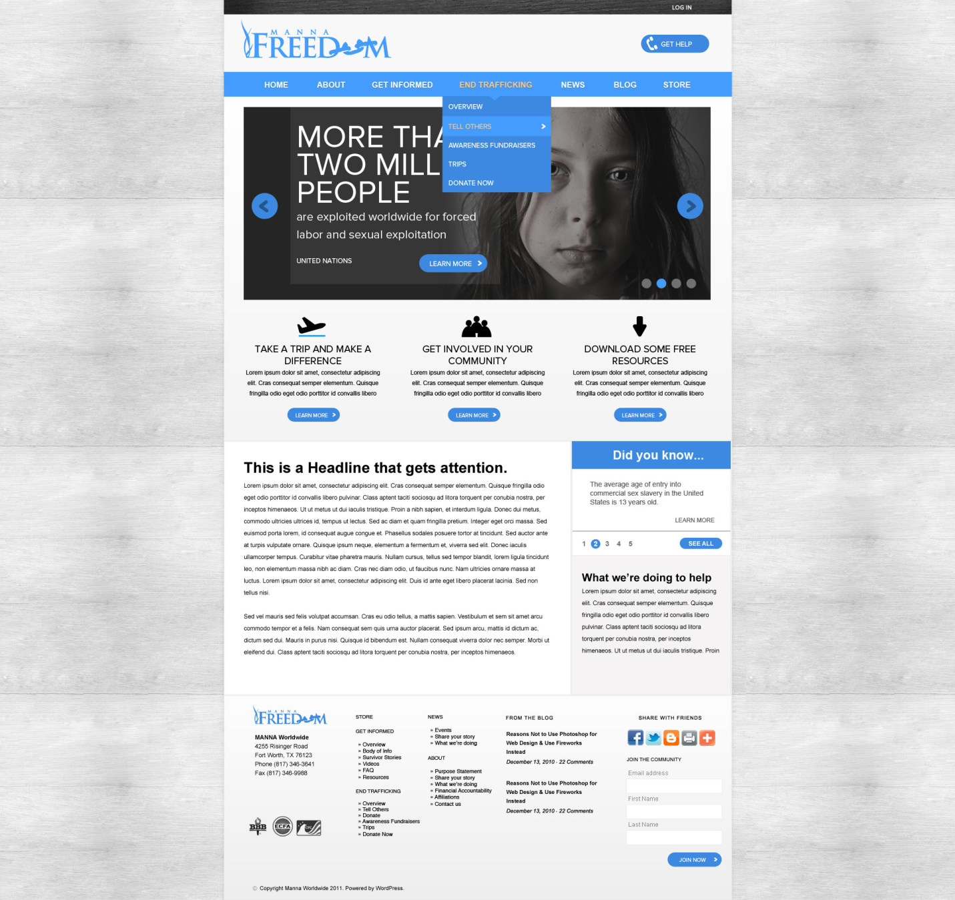MORE THAN TWO MILLION PEOPLE ARE EXPLOITATED WORLDWIDE FOR FORCED…

**Graphic-**

**Link-**Learn more>Get Informed> “What is human trafficking?”(Summary/overview)

1. SURVIVOR STORIES- REAL PEOPLE-REAL LIVES

**Graphic**-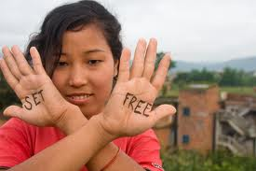

**Link-**Learn More>Get Informed>Survivor Stories & Videos

1. EVERY MINUTE TWO CHILDREN BECOME VICTIMS OF SEXUAL EXPLOITATION

**Graphic**- ;

**Link-**Learn More>Get Informed>Resource Center>10 Quick facts about Child Sex Slavery (downloadable pdf)

1. SUCCESS STORIES

**Graphic-**  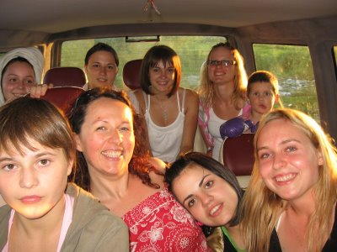

**Link-**Learn More>News>Bridge to Life Homes>Safe Haven

**Widgets under Carousel:**

1. Take a trip and make a difference.
   1. **Byline-** Experience the impact MANNA Freedom is having keeping teens out of the hands of traffickers.
   2. **Learn More**>Intervene>Trips> Redirect to MANNA trip page
2. Get Involved in your community.
   1. **Byline-** Be a world changer.
   2. **Learn More**>Intervene
3. Download some free resources.
   1. **Byline-** For parents, educators, religious leaders, medical professionals, social service personnel.
   2. **Learn More**>Get Informed>Resource Center NEED PDFs for- 10 Quick Facts about Child Sex Slavery, Sign of Sexual Exploitation, Child Protection Tips for Internet and Social Media, Top 10 characteristics of a sexual predator, Dept. HHS pamphlet for Social Service providers, Dept. HHS pamphlet for law enforcement, healthcare providers.

**This is Headline that gets attention**  (featured post section)

**EVERYDAY PEOPLE MAKING AN IMPACT**

**Graphic-** 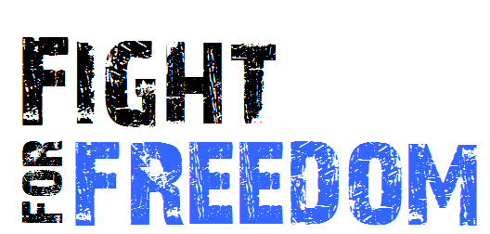

*Fight4Freedom Contest* Imagine you and your youth leader joining a 2012 MANNA Freedom trip to Ukraine! Experience firsthand the work being done to keep orphans safely out of the hands of human traffickers in Eastern Europe. Visit our Bridge to Life Homes and interact with teens anticipating a bright future as they are prepared for independent lives equipped with life and job skills training. You will be able to tour state orphanages and get to know the “castaway children of Europe”

Click here for more information or to enter contest> News> TEEN AWARENESS PROJECT>TAP (Template # 2; 2nd level subpage)

**Did you know… box on right**

1. The average age of entry into commercial sex slavery in the United States is 13 years old.
   1. **Learn More**>Get Informed
2. Most Americans are unaware sex trafficking is happening in their city. Test your knowledge.
   1. **Learn More**> Get informed>FAQ> TEST YOUR KNOWLEDGE ABOUT TRAFFICKING
3. That orphans in Eastern Europe are targets of sex trafficking.
   1. **Learn More>** NEWS> Bridge to Life Homes
4. 100,000-300,000 American children become victims of sexual trafficking annually.
   1. **Learn More>** Get informed
5. At any time 50,000 sexual predators are online searching for victims. Learn how to protect your children.
   1. **Learn More>** Get informed> Resource Center> Internet Safety Tips

**What we’re doing to help**

MANNA Freedom is dedicated to the task of raising awareness of the dangers of sex trafficking and to the prevention of teens and children from becoming victims of sexual exploitation, both domestically and internationally. Breaking Chains~ Building Lives

**Note:** bottom of page where CFC logo is we need to add our number **#27809**

**Join our community-** when they submit their info there should be a pop up window thanking them for joining up and to be on the lookout for updates. We capture their contact info (lead capture and management software) and an auto response message should go out to them immediately.